Lesson 216 – Heightfields

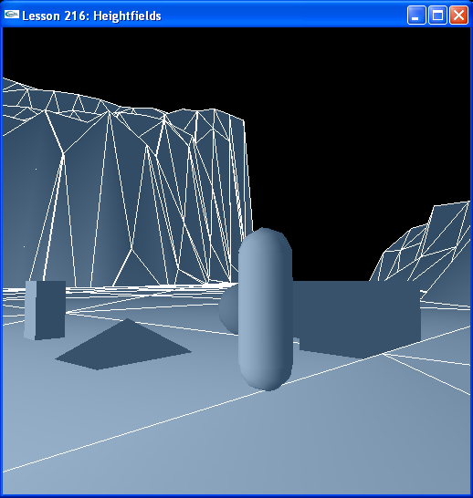

Introduction
중급자 과정의 이번 마지막 lesson 에서 우리는 height field를 사용하여 커다란 terrain 을 생성하여 그 위에 다양한 종류의 object들을 놓는다.
In this final lesson of the intermediate training programs we use a heightfield to build a large terrain to place various types of objects on.

Heightfields
우리의 모든 친숙한 object들은 InitNx()의 마지막을 장식하기위해서 뒷부분에 놓여져 있다.
All our familiar objects are back for the finale in InitNx().

NxVec3 Eye(-25,75,15);
…
NxActor* box = NULL;
NxActor* sphere = NULL;
NxActor* capsule = NULL;
NxActor* pyramid = NULL;
NxActor* concaveObject = NULL;
…
NxActor* heightfield = NULL;
…
void InitNx()
{
…
NxVec3 A = NxVec3(1,0,0);
NxVec3 B = NxVec3(0,0,1);
NxVec3 C;

C = A.cross(B);

heightfield = CreateHeightfield();

box = CreateBox(Eye + NxVec3(5,0,10), NxVec3(0.5,1,0.5), 20);
sphere = CreateSphere(Eye + NxVec3(0,0,15), 0.5, 10);
capsule = CreateCapsule(Eye + NxVec3(-5,0,10), 2, 0.5, 10);
pyramid = CreatePyramid(Eye + NxVec3(0,0,10), NxVec3(1,0.5,1.5), 10);
concaveObject = CreateConcaveObject(Eye + NxVec3(-4,0,15), NxVec3(1,1,1), 10);

gSelectedActor = box;
}

CreateHeightfield()는 가장 새로운 object 생성 함수이다. 그것을 살펴보면 여러분은 TGA 파일을 읽고 height field를 생성하기위해서 file 로부터 image data를 사용하는 것을 알아차릴 것이다.
CreateHeightfield() is the newest object creation function of the lot. Looking at it you will notice it reads in a TGA file and uses the image data from the file to create a heightfield.

NxActor* CreateHeightfield ()
{
tgaInfo* heightfield = tgaLoad("../data/MyTerrain.tga");
…
for (int i = 0; i < heightfield ->width; i++)
{
for (int j = 0; j < heightfield ->height; j++)
{
unsigned char h = (unsigned char)(*( heightfield ->imageData + i + j* heightfield ->width));
gHeightfield Verts[(heightfield ->width-i) + j* heightfield ->width].y = ((float)h/255.0)*200.0f + 10.0f;
}
}
…
// Build physical model
NxTriangleMeshDesc heightfieldDesc;
heightfieldDesc.numVertices = HEIGHTFIELD_NB_VERTS;
heightfieldDesc.numTriangles = HEIGHTFIELD_NB_FACES;
heightfieldDesc.pointStrideBytes = sizeof(NxVec3);
heightfieldDesc.triangleStrideBytes = 3*sizeof(NxU32);
heightfieldDesc.points = gTerrainVerts;
heightfieldDesc.triangles = gTerrainFaces;
heightfieldDesc.flags = 0;

heightfieldDesc.heightFieldVerticalAxis = NX_Y;
heightfieldDesc.heightFieldVerticalExtent = -1000.0f;

NxTriangleMeshShapeDesc heightfieldShapeDesc;
heightfieldShapeDesc.meshData =
gPhysicsSDK->createTriangleMesh(heightfieldDesc);

NxActorDesc actorDesc;
actorDesc.shapes.pushBack(&terrainShapeDesc);
NxActor* actor = gScene->createActor(actorDesc);

actor->userData = (void*)-1;

return actor;
}

Triangle mesh descriptor는 전 lesson들에서 두 라인들 제외하고는 mesh object들을가지고 정확하게 같은 방법으로 구성되어지는 것을 주목해라.
Notice the triangle mesh descriptor is constructed in exactly the same fashion as with the mesh objects in the previous lessons with the exception of two lines:

heightfieldDesc.heightFieldVerticalAxis = NX_Y;
heightfieldDesc.heightFieldVerticalExtent = -1000;

이것은 heightfield 에 triangle mesh 을 가리키게된다. 그것의 natural up-vector는 y 축이고 그것은 원점 아래 1000 unit들 까지 확장되어진다. Y = -1000 에서의 평면과 height field의 표면에서의 모든 object들은 height field 의 표면이 깨끗해질때까지 앞쪽으로 밀려날 것이다.
This designates the triangle mesh as a heightfield. Its natural up-vector is the y-axis and it extends 1000 units below the origin, that is, all objects between the plane at y = -1000 and the surface of the heightfield will be pushed upward to until they clear the surface of the heightfield.

Conclusion
여러분은 이제 height field 를 triangle mesh로부터 구성하는 방법을 알고 있고 예전 Lesson들에서 triangle mesh로부터 simple comvex object, simple concave object 그리고 PMap 을 구성하는 방법을 배워왔다. 이것으로 중급 training program 을 끝맺는다.
You know now how to construct a heightfield from a triangle mesh and have learned in previous lessons how to construct a simple convex object, a simple concave object, and a PMap from a triangle mesh. This concludes the intermediate training programs.

Related Classes, Functions, and Parameters
NxTriangleMeshDesc
heightFieldVerticalAxis
heightFieldVerticalExtent

NxHeightFieldAxis
NX_X
NX_Y
NX_Z
NX_NOT_HEIGHTFIELD

